|  |  |  |  |
| --- | --- | --- | --- |
| Panel specification | | | |
| Contact: | Asier Vidal | **Date** | 05/02/2018 |
| Email: | a.vidal@bizintekinnova.com | **Project** | MIN_MOW |
| Tel: | +34 944372696 | **PCB** | MIN_MOW_03_V3_Panel |

# 1. Panel specification

Panel Reference:

|  |  |
| --- | --- |
| Quantity: | 1 Panels |
| Board dimensions: | 85.525mmx 38mm (MOWAY); 12.5mm x 38mm (IR) |
| Panel dimensions: | 199.543mm x 125.525mm |
| Number of Layers: | 4 |
| Material: | ● Standard Tg 140ºC FR4  □ High Tg 170ºC FR4  □ Other: |
| Total Board Thickness: | 1mm |
| Total Copper thickness | 0.035 |
| UL94 Flame Class | No |
| Finish: | □ HASL – RoHS  ● ENIG Inmersion Gold - RoHS  □ Inmersion Silver - RoHS  □ Inmersion Tin - RoHS |
| Solder mask | BLACK Top and Bottom |
| Silkscreen: |  |
| Electrical test: | Yes |
| Marking: |  |
| Notes: | Mechanical 4 defines PCB milling |

# 2. Layerstack

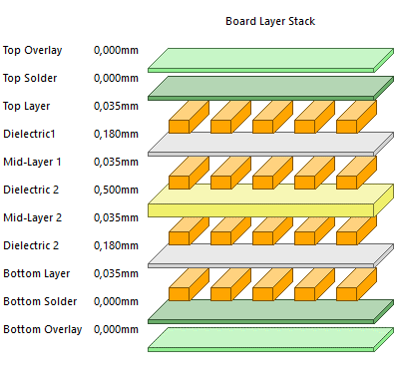

# 3. Attached Files

|  |  |  |
| --- | --- | --- |
| DE_MIN_MOW_Moway_V3 Panel specification | pdf | Board documentation files. |
| MIN_MOW_Moway_V3 Panel | gtl | Top Layer |
| MIN_MOW_Moway_V3 Panel | gto | Top Silkscreen |
| MIN_MOW_Moway_V3 Panel | gts | Top Solder mask |
| MIN_MOW_Moway_V3 Panel | gtp | Top Solder Paste |
| MIN_MOW_Moway_V3 Panel | g1 | Mid-Layer1 |
| MIN_MOW_Moway_V3 Panel | g2 | Mid-Layer2 |
| MIN_MOW_Moway_V3 Panel | g3 | Mid-Layer3 |
| MIN_MOW_Moway_V3 Panel | g4 | Mid-Layer4 |
| MIN_MOW_Moway_V3 Panel | g5 | Mid-Layer5 |
| MIN_MOW_Moway_V3 Panel | g6 | Mid-Layer6 |
| MIN_MOW_Moway_V3 Panel | gbl | Bottom Layer |
| MIN_MOW_Moway_V3 Panel | gbo | Bottom Silkscreen |
| MIN_MOW_Moway_V3 Panel | gbs | Bottom Solder Mask |
| MIN_MOW_Moway_V3 Panel | gbp | Bottom2 Solder Paste |
| MIN_MOW_Moway_V3 Panel | gko | Keepout |
| MIN_MOW_Moway_V3 Panel | gm4 | Milling |
| MIN_MOW_Moway_V3 Panel-NonPlated | txt | Round Holes Non plated |
| MIN_MOW_Moway_V3 Panel-Plated | txt | Round Holes plated |
| MIN_MOW_Moway_V3 Panel | drl | NC Drill data |
|  |  |  |

# 4. Drawings

